 | American International University-Bangladesh (AIUB)  Department of Computer Science
 | Course Name: COMPUTER GRAPHICS |  | Course Code: CSE 4118
 | Faculty Name: DIPTA JUSTIN GOMES |  | Semester: FALL 2025-2026
 | Section: J  Student Name: NILOY PAUL |  | MID Term LAB Task-2  Student ID: 23-51773-2

DDA and Integer Pixel Grid
1. Construct a OpenGL Program containing the following conditions:
a. Use a separate init() function to declare your own co-ordinate system. Use the
range (-100, 100, -100, 100).
b. Construct a display function using DDA Algorithm to generate a straight line
with input: X1, Y1 (initial vertex) and Xn,Yn (Final Vertex). Consider all three
conditions of the DDA Algorithm while implementing the algorithm.
c. Create two lines as given below using DDA algorithm:
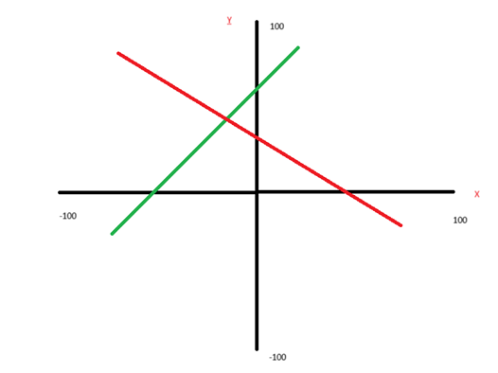

OpenGL Code

#include <windows.h>
#include <iostream>
#include <cmath>
#include <algorithm>
#include <GL/gl.h>
#include <GL/glut.h>
using namespace std;

float a1,b1,a2,b2,c1,d1,c2,d2;

void drawAxes(){
glColor3f(0,0,0);
glBegin(GL_LINES);
glVertex2i(-100,0); glVertex2i(100,0);
glVertex2i(0,-100); glVertex2i(0,100);
glEnd();
}

void dda(float X1,float Y1,float X2,float Y2,int r,int g,int b){
float m=(Y2-Y1)/(X2-X1);
glColor3ub(r,g,b);
glBegin(GL_POINTS);
if(X1>X2){swap(X1,X2);swap(Y1,Y2);m=-m;}
if(Y1>Y2){swap(Y1,Y2);m=-m;}
if(m<=1){
while(X1<X2 && Y1<Y2){
X1=X1+1;
Y1=Y1+m;
glVertex2i(round(X1),round(Y1));
}
}else{
while(X1<X2 && Y1<Y2){
X1=X1+(1/m);
Y1=Y1+1;
glVertex2i(round(X1),round(Y1));
}
}
glEnd();
}
void display(){
glClear(GL_COLOR_BUFFER_BIT);
drawAxes();
dda(a1,b1,a2,b2,255,0,0);
dda(c1,d1,c2,d2,0,255,0);
glFlush();
}

void init(){
glClearColor(1,1,1,0);
glPointSize(4);
glMatrixMode(GL_PROJECTION);
glLoadIdentity();
gluOrtho2D(-100,100,-100,100);
}
int main(int c,char** v){
cout<<"Line 1 (X1 Y1 X2 Y2): "; cin>>a1>>b1>>a2>>b2;
cout<<"Line 2 (X1 Y1 X2 Y2): "; cin>>c1>>d1>>c2>>d2;
glutInit(&c,v);
glutInitDisplayMode(GLUT_SINGLE|GLUT_RGB);
glutInitWindowSize(600,600);
glutCreateWindow("DDA");
init();
glutDisplayFunc(display);
glutMainLoop();
return 0;
}

Output

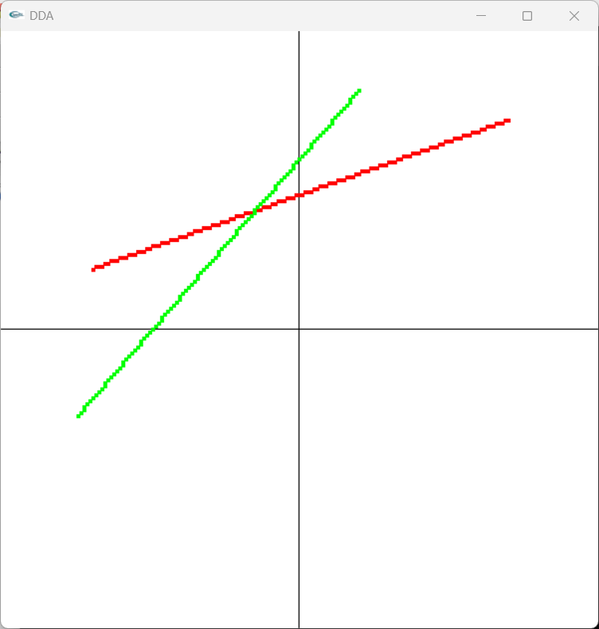

THE END

